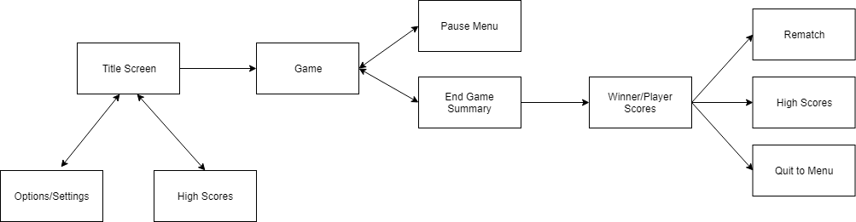

Figure 1: Potential menu flow for our game

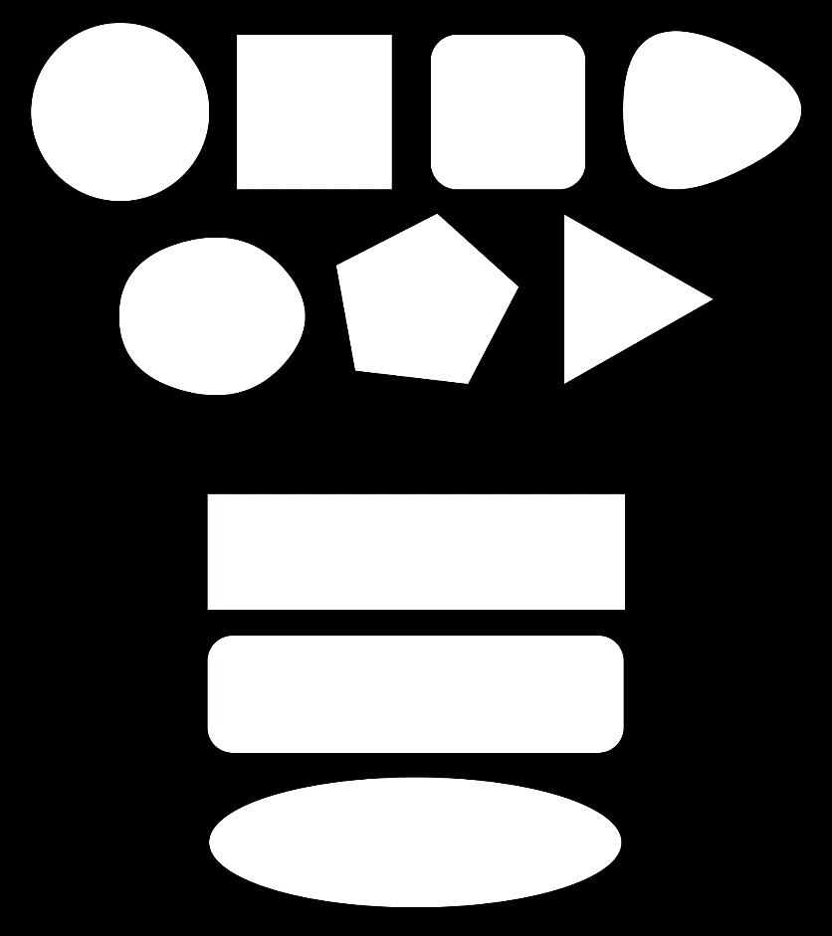

Figure 2: Considering different basic shapes and icons for button designs.

Icons used from Egor Rumyantsev and Dave Gandy from flaticons.com

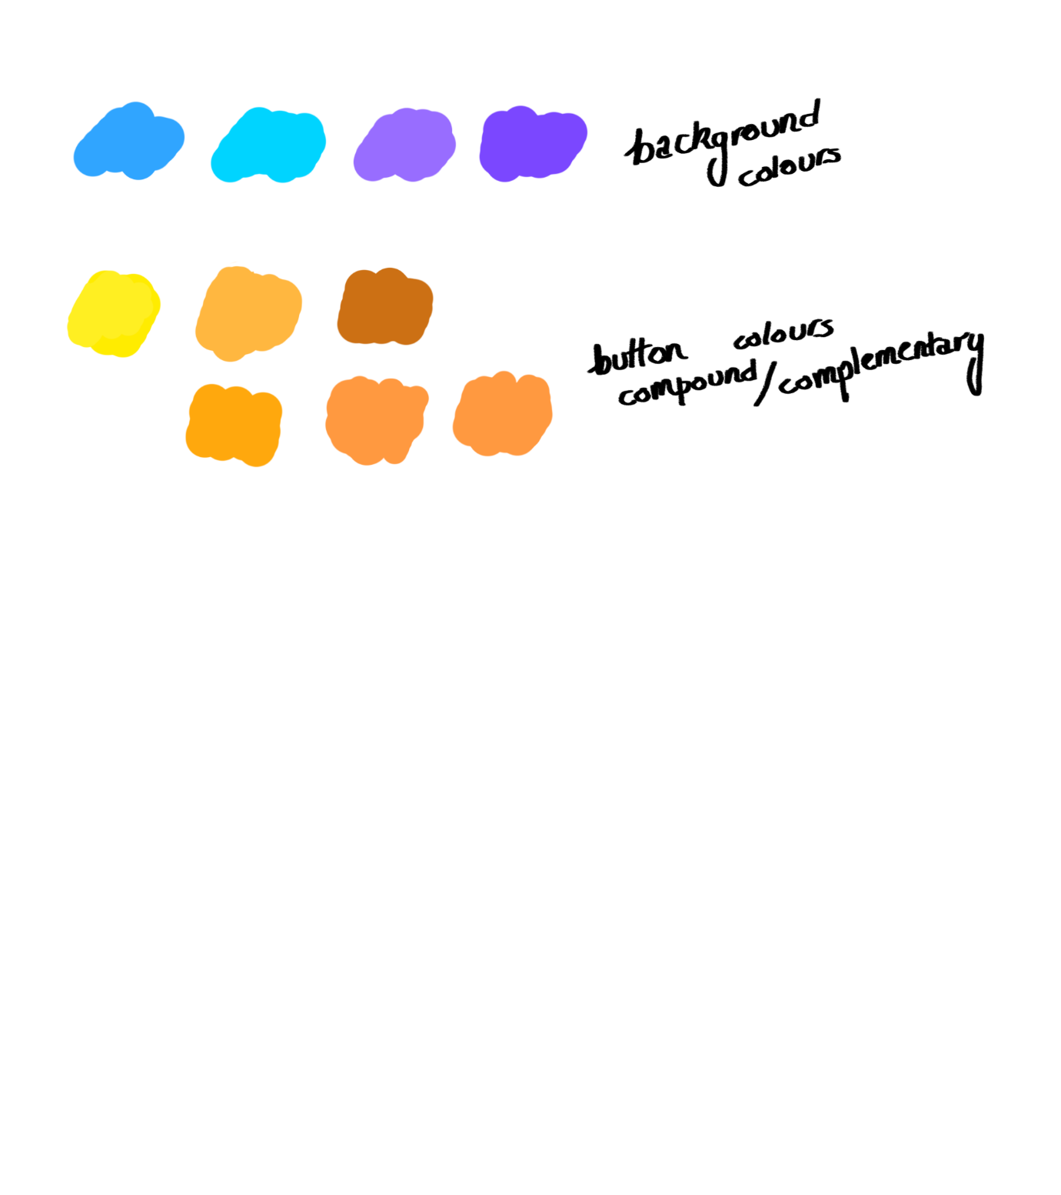

Figure 3: Looking at different colour options, focusing primarily on compound and complementary colours using '[Adobe Colour Wheel](https://color.adobe.com/create/color-wheel/)'

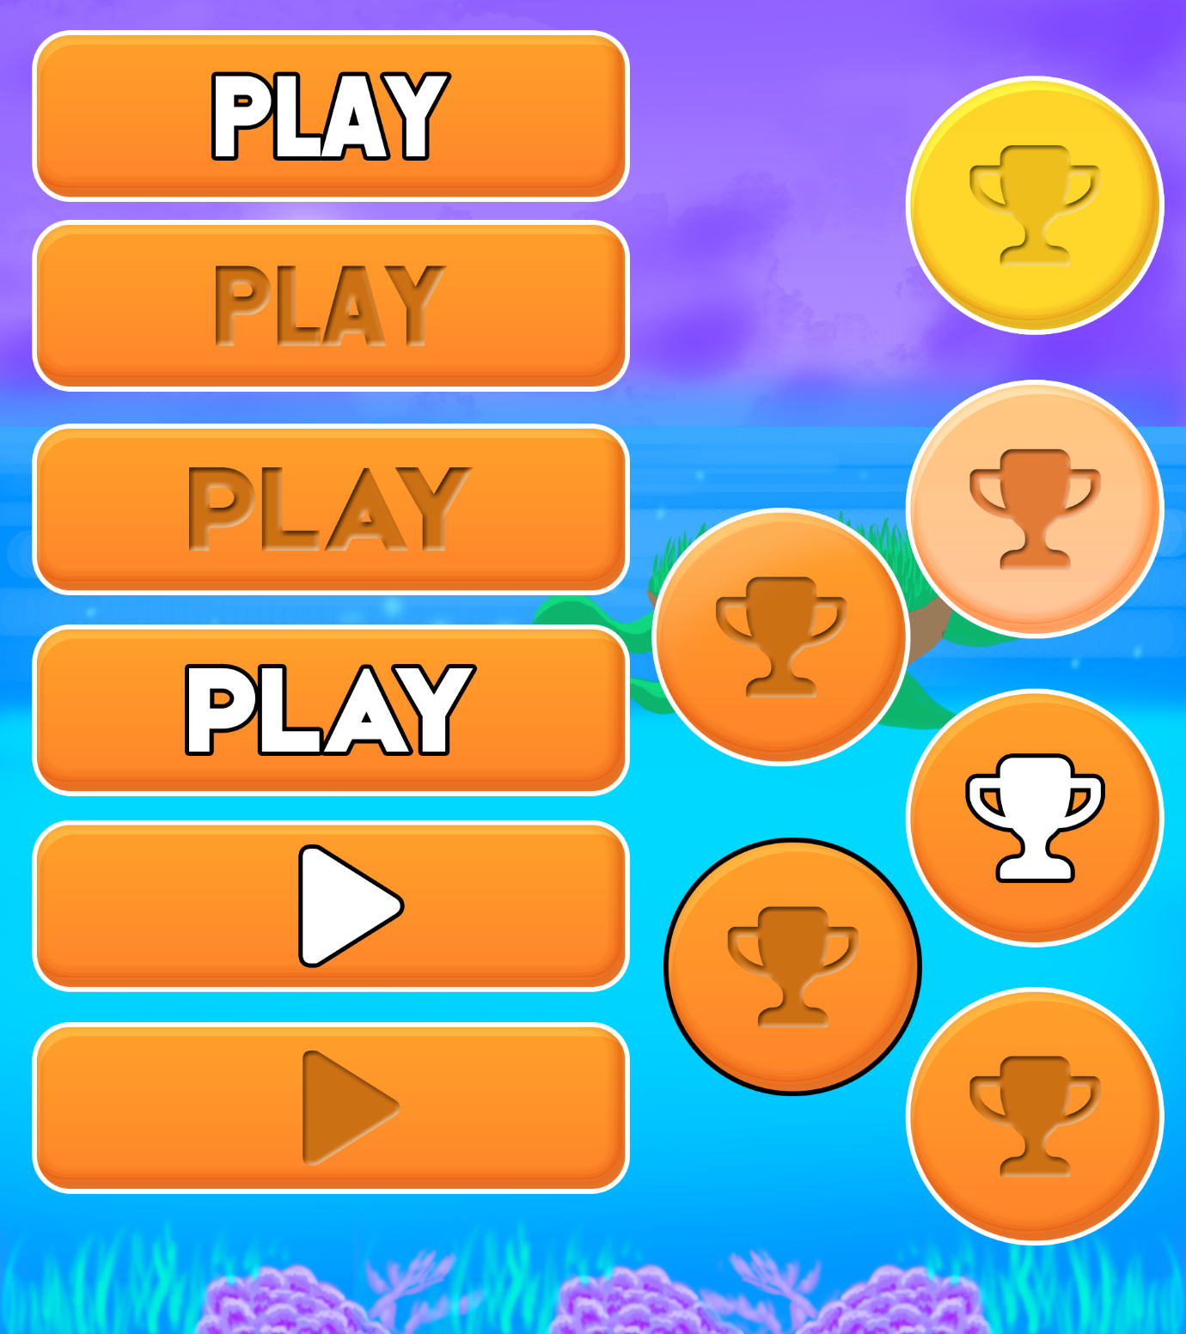

Figure 4: Considering different button designs using an iterative procress

References

<http://www.paladinstudios.com/2012/04/23/the-8-step-guide-to-interface-design-for-iphone-games/>

<https://gamedevelopment.tutsplus.com/tutorials/game-ui-by-example-a-crash-course-in-the-good-and-the-bad--gamedev-3943>

<http://poker-developers.com/blog/mobile-game-design>

<https://www.thoughtco.com/contrasting-colors-in-design-1078274>

<http://bashooka.com/inspiration/ui-design-examples-from-mobile-games/>

<https://www.scirra.com/tutorials/1398/how-to-design-professional-looking-mobile-game-buttons>